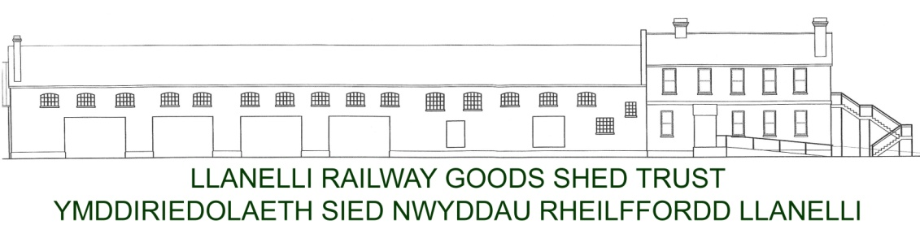

Friends Membership Application Form

Membership is free but you may make a donation if you wish. Please complete the form below and send together with any donation to Richard Roper, 24 Harries Avenue, Llanelli, SA15 3LF. If you are a taxpayer and able to take advantage of Gift Aid please tick the relevant box or boxes in the Gift Aid section below and sign the form.

NAME ………………………………………………………….  ADDRESS ………………………………………………………….  ………………………………………………………….  …………………………………………………………. | TEL. NO …………………………………  EMAIL ADDRESS ……………………………………………………

I enclose cash/cheque for ………….Cheques should be made payable to: Llanelli Railway Goods Shed Trust

Data Protection
If you would like to allow the Trust permission to contact you by any communication methods please tick the relevant boxes below to comply with the General Data Protection Regulation.
I give the Llanelli Railway Goods Shed Trust permission to contact me by:
Email ☐ Telephone ☐ Post ☐

Gift Aid
Please treat as Gift Aid donations all qualifying gifts of money made
Today ☐ In the past four years ☐ In the future ☐

I confirm I have paid or will pay an amount of Income Tax for the current year (6th April to 5th April) that is at least equal to the amount of tax that all the charities (and Community Amateur Sports Clubs) that I donate to will reclaim on my gifts for the current tax year. I understand that other taxes such as VAT and Council Tax do not qualify. I understand the charity will reclaim 25p of tax on every £1.00 that I have given.

Signature ………………………………………….. Date …………………….

